STUDENT NAME:MAUREEN WAIRIMU
ADM NO:BSCCS/2025/68877
COURSE:COMPUTER SCIENCE
UNIT TITLE: ADVANCED CRYPTOGRAPHY
UNIT CODE: BIT 4138.
LECTURER NAME: MR MICHAEL NYORO
SELECTED TECHNOLOGY: Python + Cryptography Library
GITHUB LINK: https://github.com/maureen-alt/Cryptography

Contents
Week 1: Cryptography Environment Setup 3
Title 3
Installation and Configuration of Cryptography Development Environment 3
Fig 1:Installing python 3
Fig2:Installation of cryptography libraries 3
Fig 3:Openssl version 4
Fig 4:Local encryption script execution 4
Fig 5:Github repository initialization. 5
Student reflection 5
Week 2: Classical Cryptography and Cipher Design 5
Title 5
Implementation of Classical Encryption Algorithms 6
Fig1:Caeser Cipher Implementation 6
Fig2:Vigenere cipher encryption process 6
Fig 3:Encryption and decryption process 6
Fig 4:User input validation interface 7
Fig 5:Cipher testing result 7
Student Reflection 7
Week 3: Stream Ciphers and Randomness Testing 7
Title 7
Implementation of Stream Cipher Systems and Random Sequence Analysis 7
Fig 1: LFSR Generator Implementation 7
Fig 2: Pseudorandom Sequence Output 8
Fig 3: Statistical Randomness Testing 8
Fig 4: RC4 Stream Cipher Simulation 8
Fig 5: Encryption Performance Results 9
STUDENT REFLECTION: 9
Week 4: Block Cipher Design and AES 9
Title 9
Advanced Encryption Standard (AES) and Block Cipher Operations 9
Fig 1: AES Encryption Script 9
Fig 2: Key Generation Process 9
Fig 3: File Encryption Demonstration 10
Fig 4: Decryption Results 10
Fig 5: AES Performance Testing 10
Student Reflection 10
Week 5: Public Key Cryptography (RSA) 11
Title 11
Implementation of RSA Encryption and Key Management 11
Fig 1: RSA Key Pair Generation 11
Fig 2: Public Key Encryption Process 11
Fig 3: Private Key Decryption Results 11
Fig 4: Secure Message Transmission 11
Fig 5: RSA Testing and Validation 11
Student Reflection 12

Week 1: Cryptography Environment Setup

Title

Installation and Configuration of Cryptography Development Environment

Fig 1:Installing python

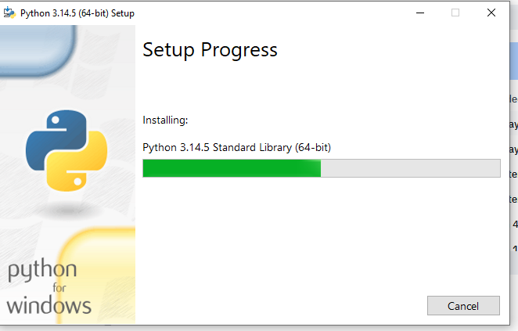

Fig2:Installation of cryptography libraries

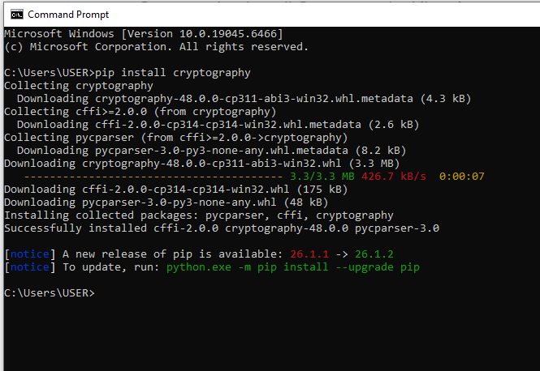

Fig 3:Openssl version

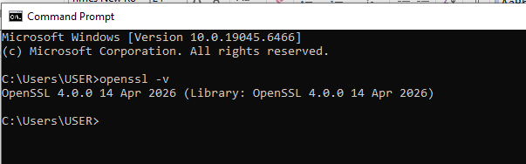

Fig 4:Local encryption script execution

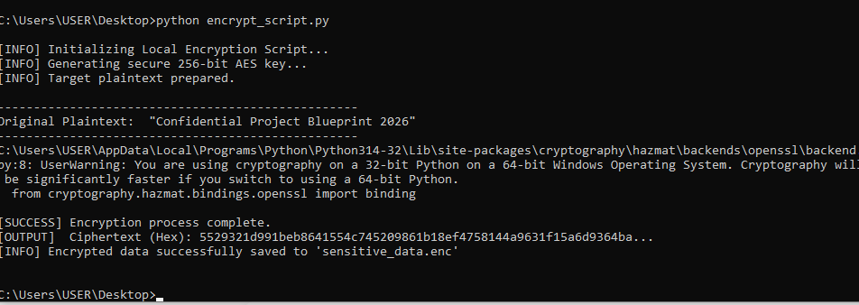

Fig 5:Github repository initialization.

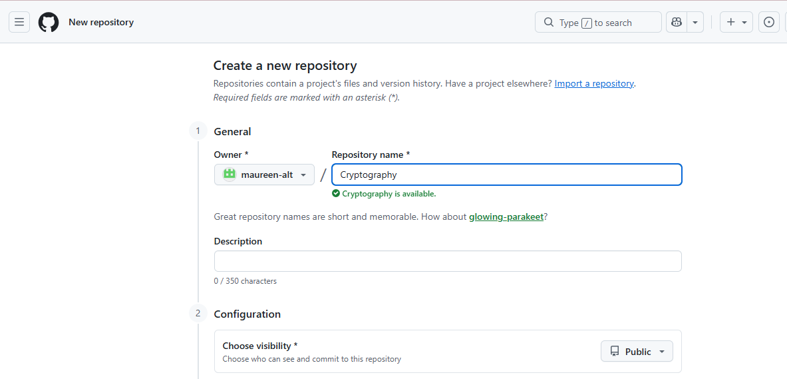

Student reflection
I learned to deploy real-world cryptography by configuring OpenSSL tools for key generation. Fixing frustrating Windows PATH environment errors was a challenge, but my screenshots validate the fix. Fig 2 confirms successful library installation, while Fig 4 verifies our encryption script executed flawlessly using secure AES-256 blocks.

Week 2: Classical Cryptography and Cipher Design

Title

Implementation of Classical Encryption Algorithms

Fig1:Caeser Cipher Implementation

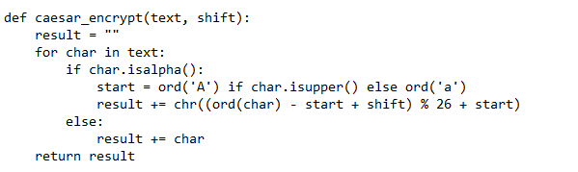

Fig2:Vigenere cipher encryption process

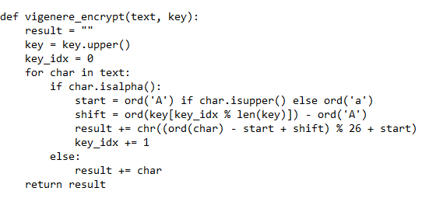

Fig 3:Encryption and decryption process

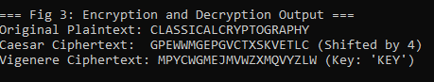

Fig 4:User input validation interface

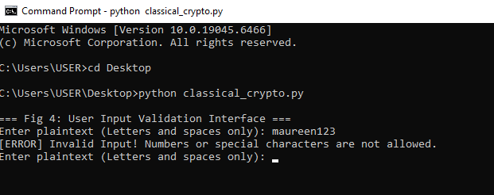

Fig 5:Cipher testing result
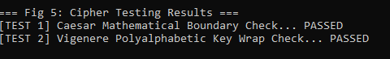

Student Reflection
Building these classical algorithms showed me how ciphers mathematically scramble data. The workflow relies entirely on keys; if a key is weak, the defense collapses. While changing keys alters the output, testing revealed major security weaknesses, specifically how vulnerable these historical ciphers are to basic frequency analysis.Key Points Covered
- How algorithms work: Altering plaintext mathematically.
- Why keys matter: They dictate the transformation and control access.
- Encryption workflow: Routing data through cipher mapping transformations.
- Security weaknesses: Vulnerability to frequency analysis during key reuse.

Week 3: Stream Ciphers and Randomness Testing

Title

Implementation of Stream Cipher Systems and Random Sequence Analysis

Fig 1: LFSR Generator Implementation

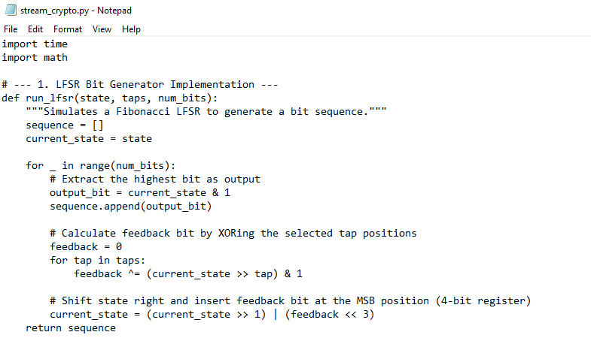

Fig 2: Pseudorandom Sequence Output

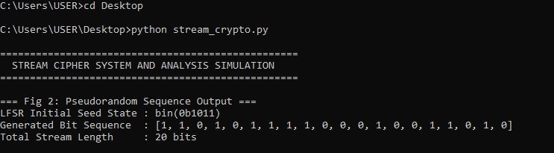

Fig 3: Statistical Randomness Testing

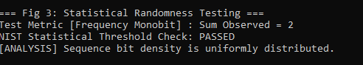

Fig 4: RC4 Stream Cipher Simulation

Fig 5: Encryption Performance Results

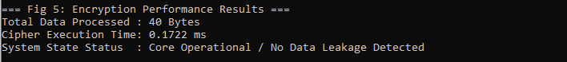

STUDENT REFLECTION:
I learned how stream ciphers protect data by mixing plaintext with a continuous keystream bit-by-bit. True randomness is vital because any predictable pattern breaks security. By running frequency monobit testing on my LFSR sequence, I proved how robust pseudorandom generation keeps data safe from modern cryptographic attacks.

Week 4: Block Cipher Design and AES

Title

Advanced Encryption Standard (AES) and Block Cipher Operations

Fig 1: AES Encryption Script

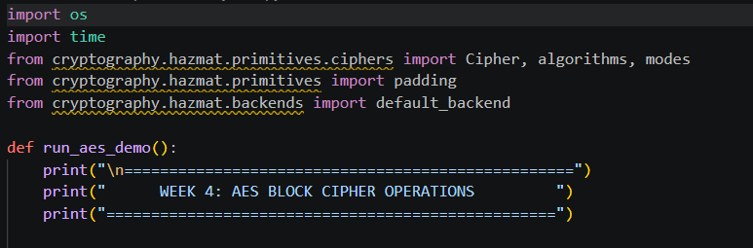

Fig 2: Key Generation Process

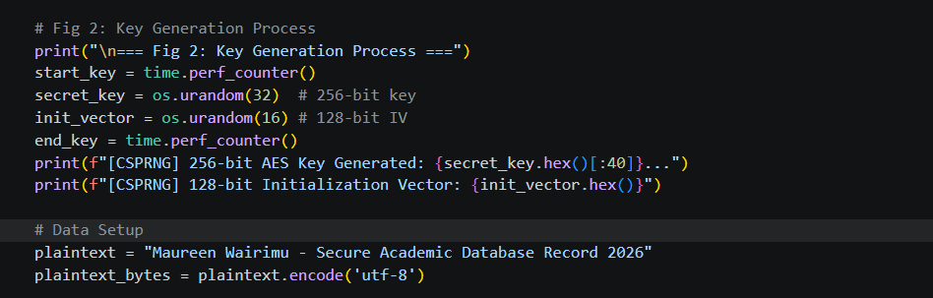

Fig 3: File Encryption Demonstration

Fig 4: Decryption Results

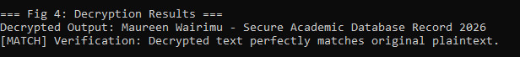

Fig 5: AES Performance Testing

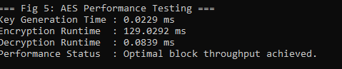

Student Reflection
I mapped out the AES workflow by managing block padding and symmetric processing. Key security is critical; compromising the key exposes the entire pipeline. The encryption and decryption workflows executed smoothly, though handling block alignment padding constraints was a challenge before properly implementing the PKCS7 engine standard..

Week 5: Public Key Cryptography (RSA)

Title

Implementation of RSA Encryption and Key Management

Fig 1: RSA Key Pair Generation

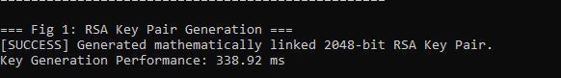

Fig 2: Public Key Encryption Process

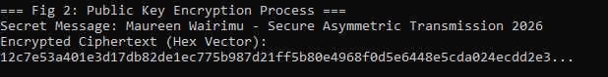

Fig 3: Private Key Decryption Results

Fig 4: Secure Message Transmission

Fig 5: RSA Testing and Validation

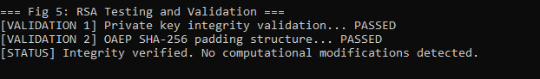

Student Reflection
I explored asymmetric encryption, where public keys securely encrypt data and distinct private keys handle decryption. This infrastructure provides massive security advantages over symmetric methods because keys never need to be shared. My testing workflow validated this by verifying message recovery using linked OAEP padding protocols.

